**OOP HW20 Individual Exercise Test Cases**

**DATE: 10th february 2022**

1 ALMACHE LITARDO ANDERSON MOISES

2 ALTAMIRANO BENALCAZAR CRISTHIAN ALEXANDER

3 ALVAREZ RAMIREZ MICHELLE ESTEFANIA

4 ANDRADE CARATE ALAN DAMIAN

5 ANDRANGO ESPINOSA ALEX PAUL

6 ARROBA SOLORZANO CRISTIAN ALEXANDER

7 ASUMAZA GUALOTO DYLAN ALEXANDER

8 BRAVO RODRIGUEZ KATHERIN DAYANNE

9 BRAVO VILLALOBOS CHRISTIAN DAVID

10 BUSTILLOS MONTENEGRO PABLO SEBASTIAN

11 CADENA ROMAN BENJAMIN ABEL

12 CAISATOA RAMIREZ SEBASTIAN BERNARDO

13 CALDERON MERCHAN ANDY JOSUE

14 CORREA RUIZ KERLY YADIRA

15 CRUZ PANTOJA DARLING MICAELA

16 DE LA CRUZ QUINGA ALEJANDRO SEBASTIAN

17 EIVAR DAGUA JAIME MAURICIO

18 GARCIA BARRETO MAYERLY PRISSILLA

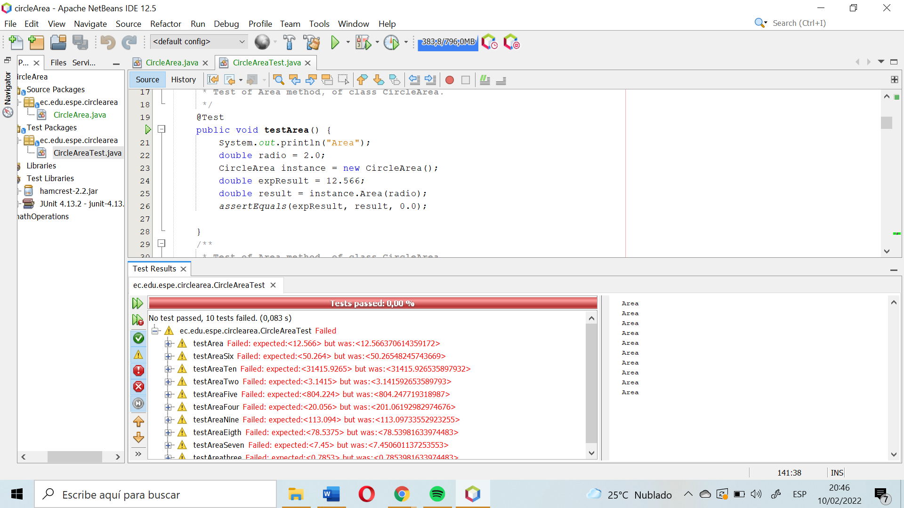

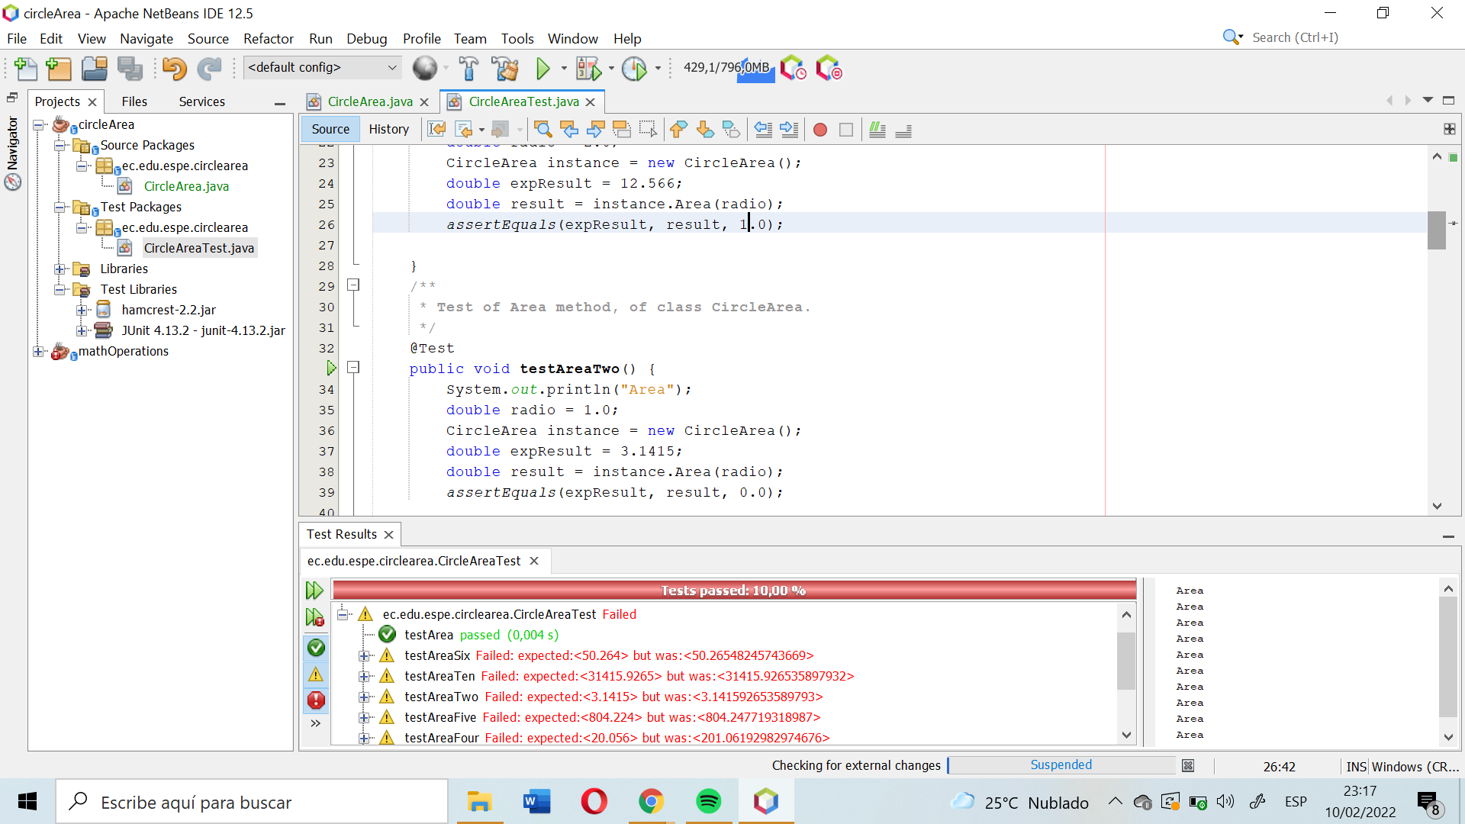

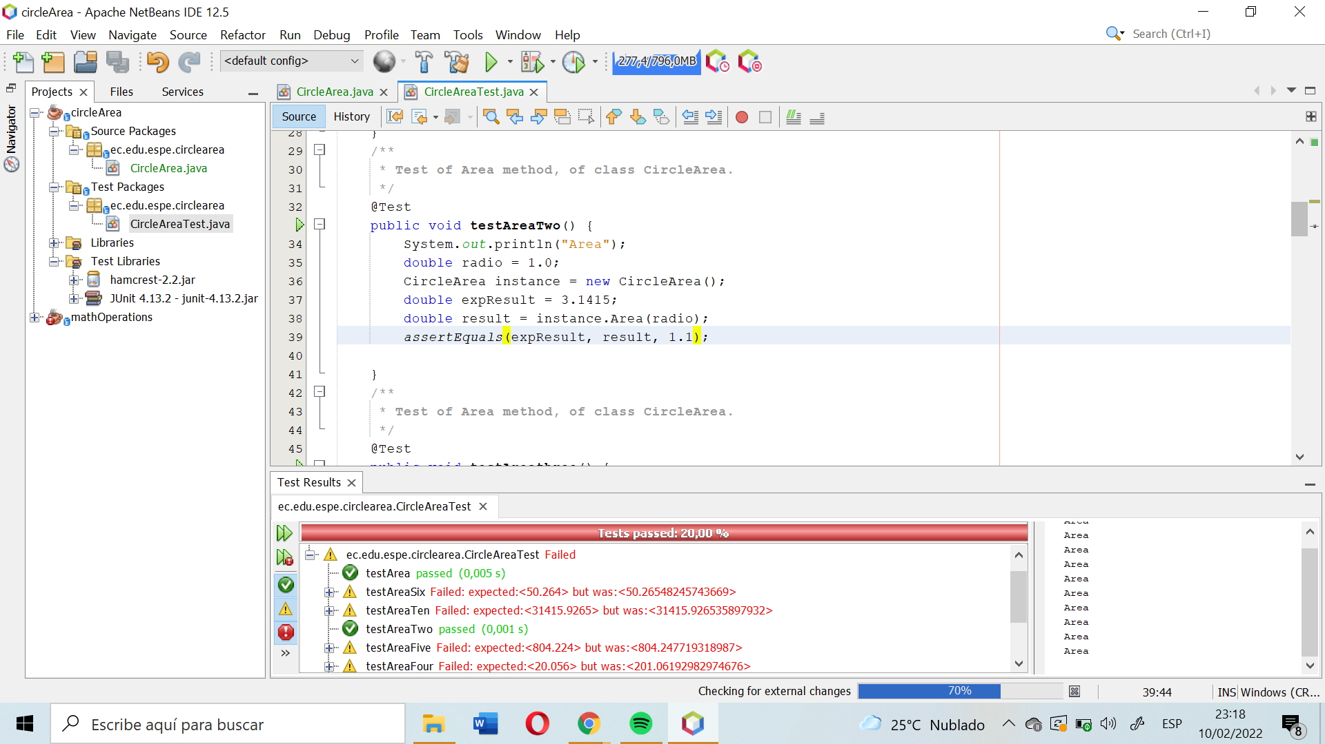

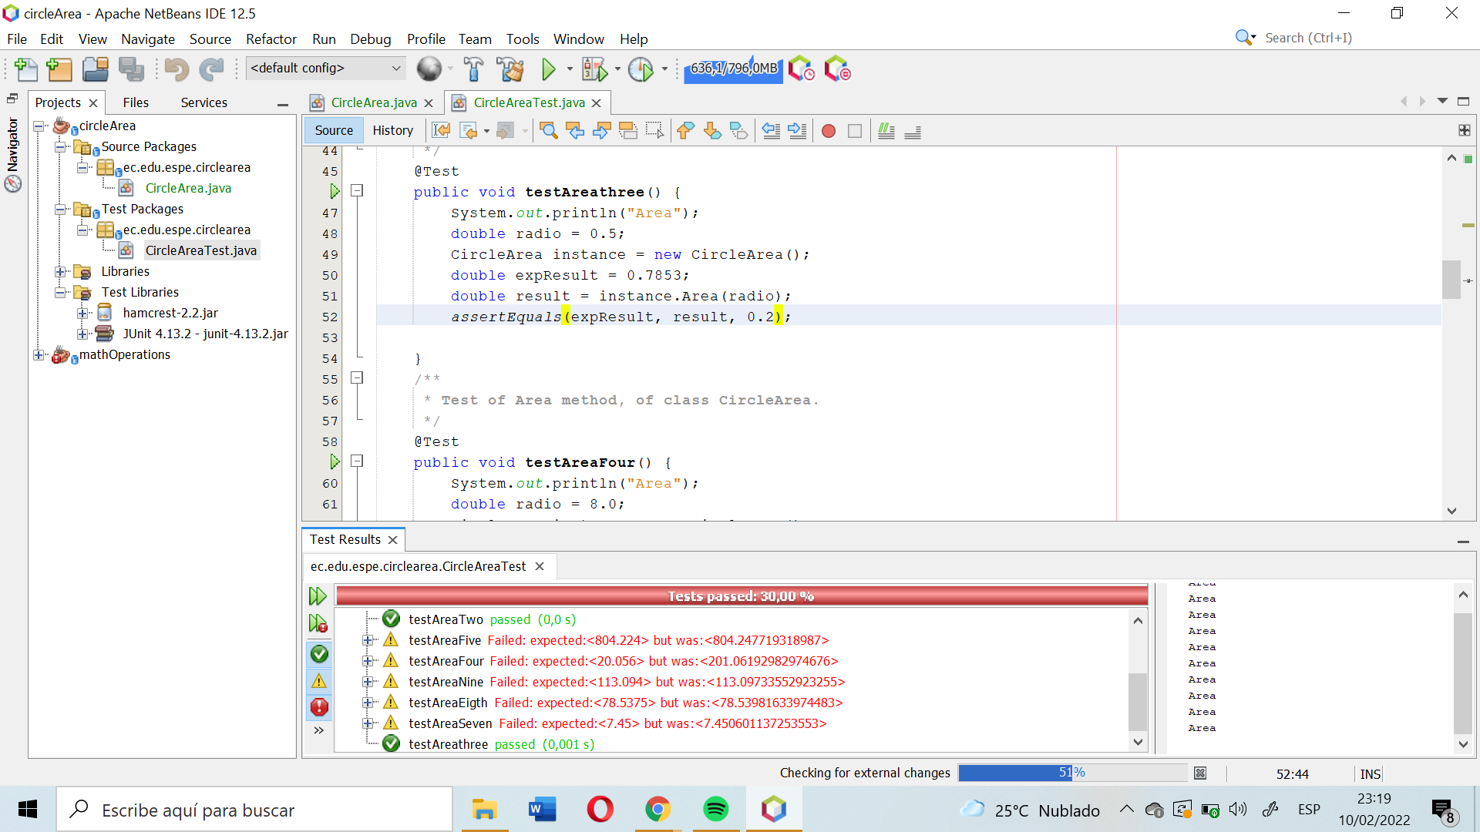

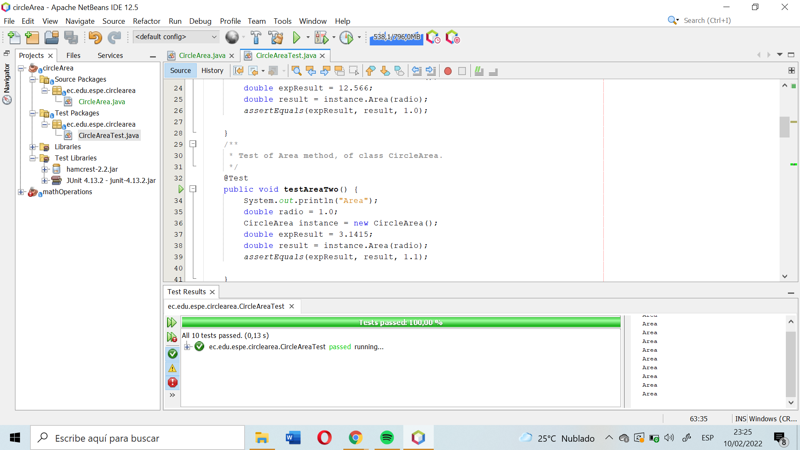

19 GOMEZ DIAZ MELISSA MALAYCA

20 GUAMAN VEJARANO ANGEL DAVID

21 GUITARRA SANCHEZ JHON ALEXANDER

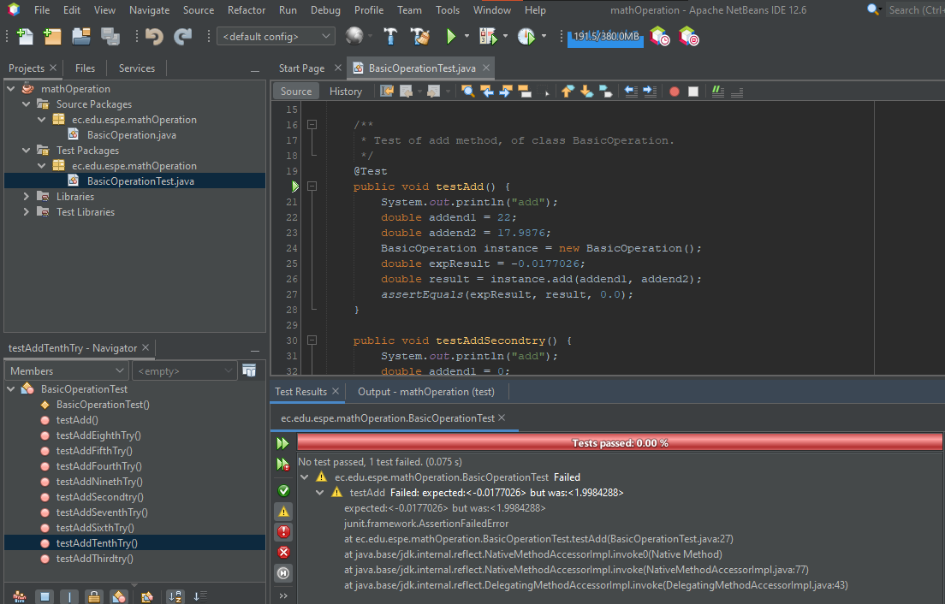

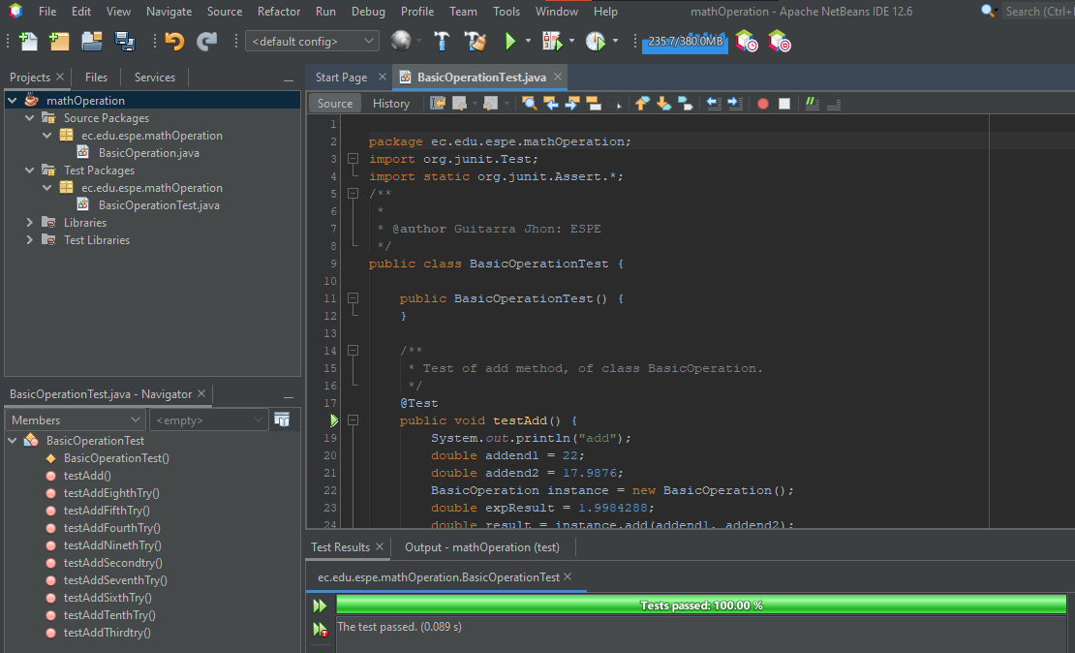

22 GUZMAN LOPEZ JOSE DAVID

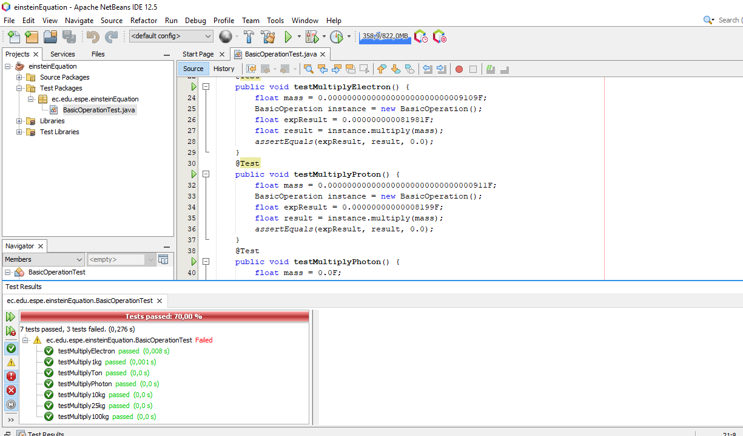

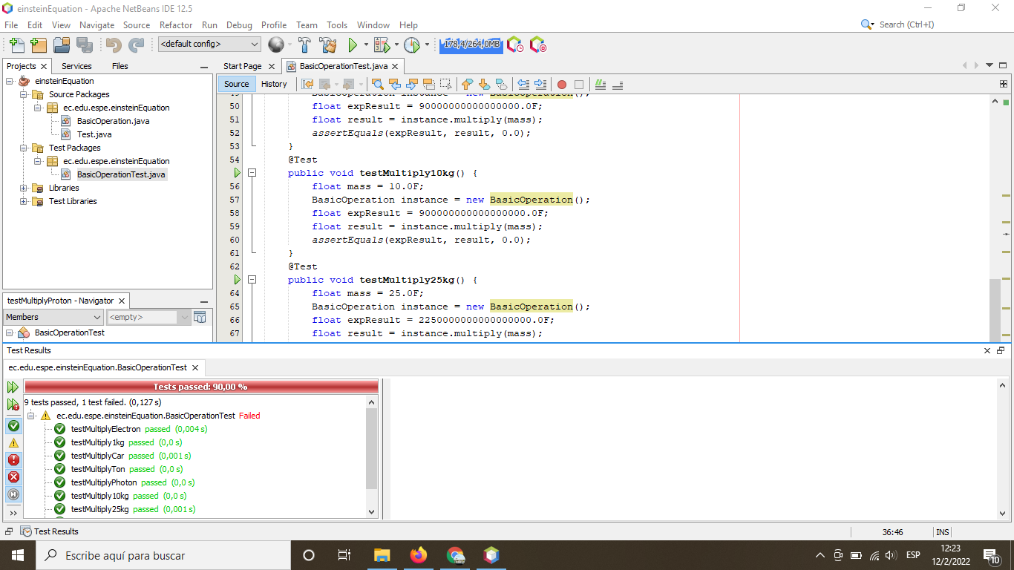

23 INSUASTI LOPEZ JONATHAN ESTEBA

24 LANDAZURI SEGOVIA MATEO ISRAEL

25 LINCANGO CRIOLLO JOSE DANIEL

26 MAISINCHO PAUCAR RICHAR ALEXANDER

27 MALDONADO BASTIDAS MATEO STEFANO

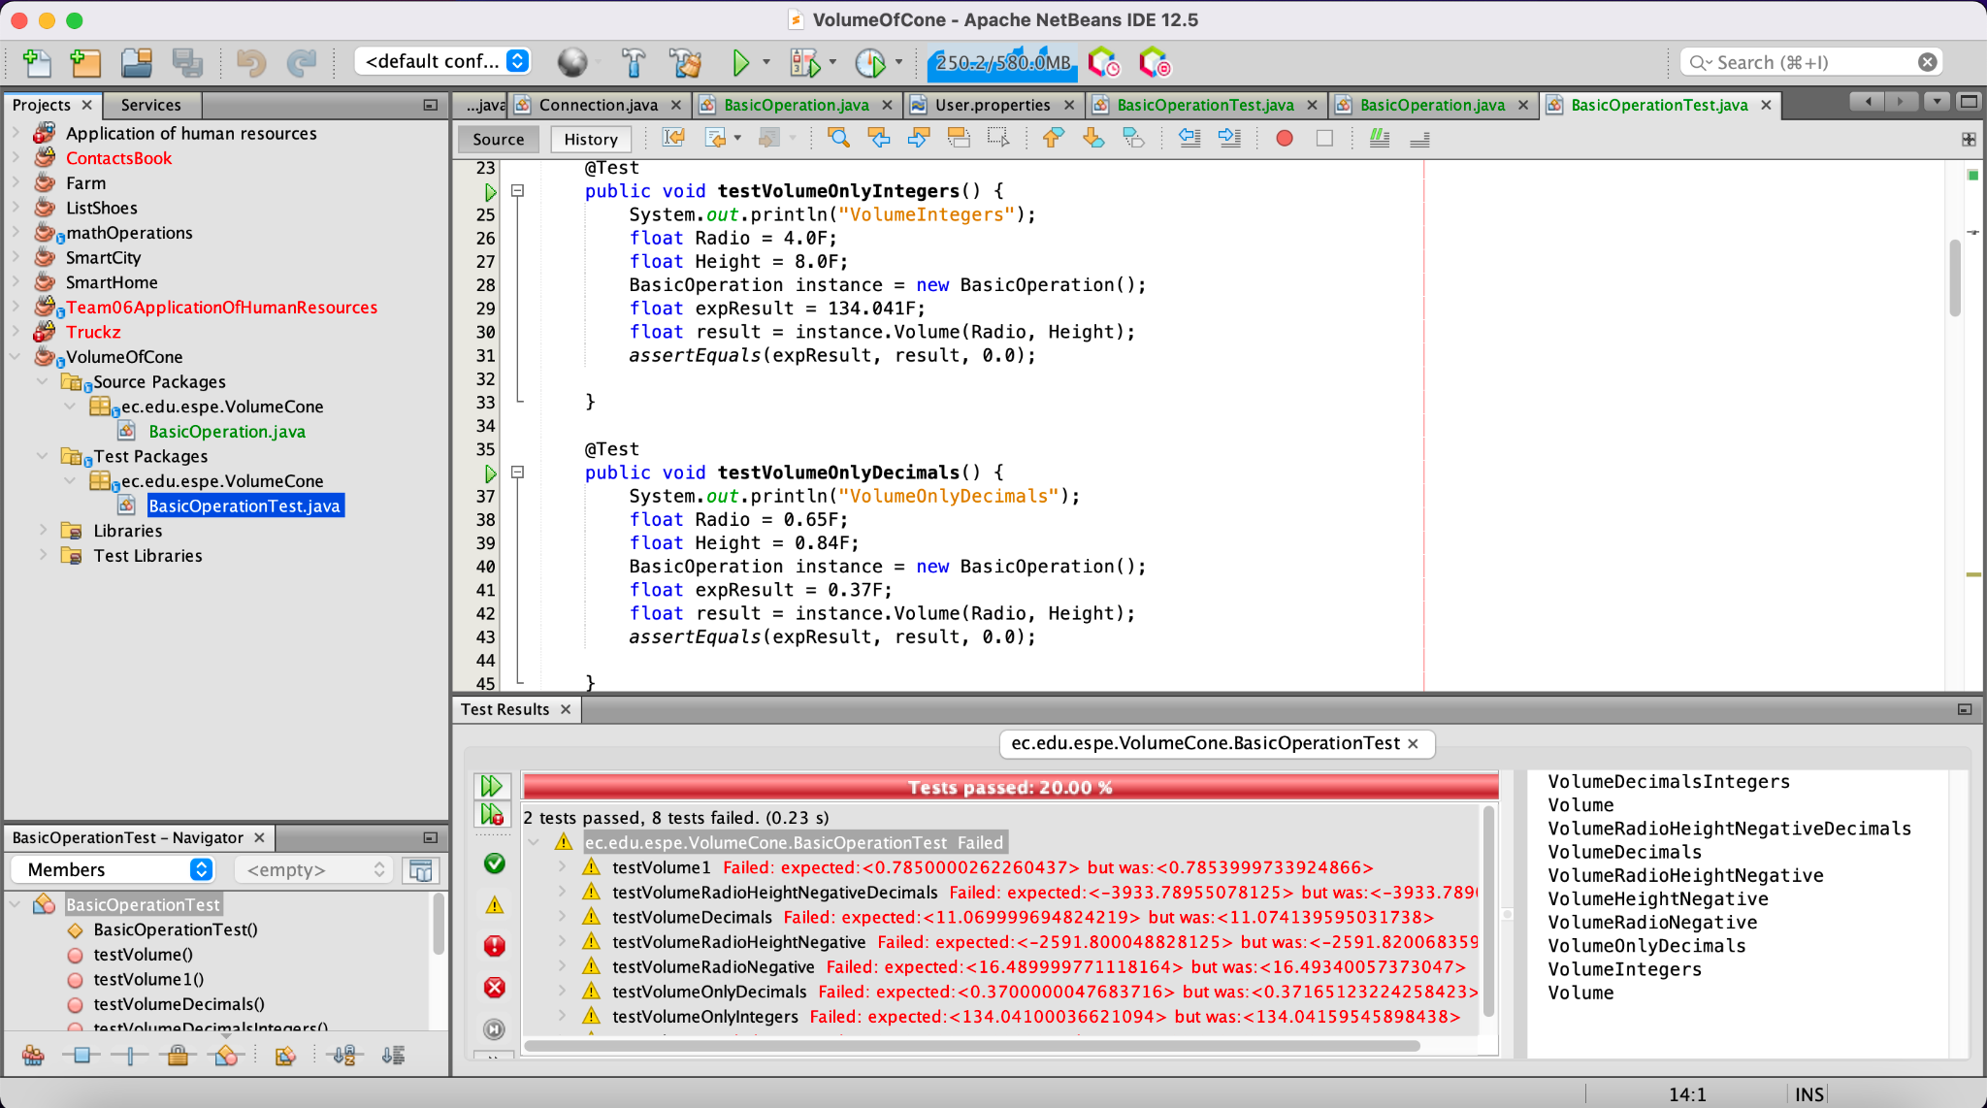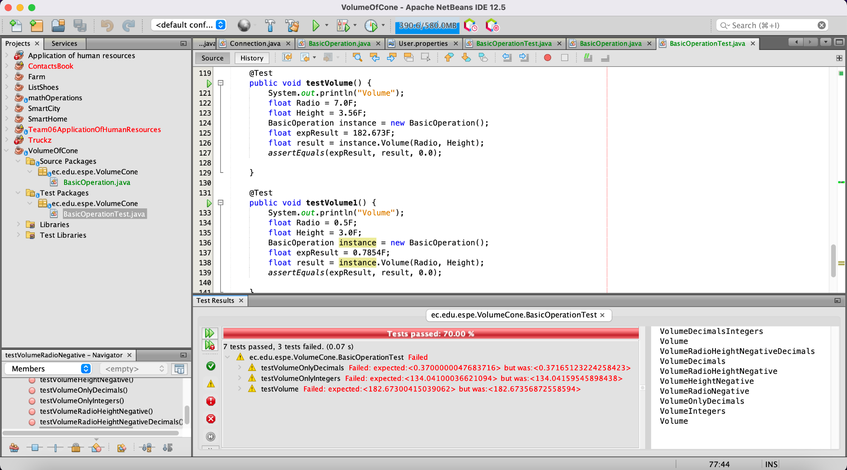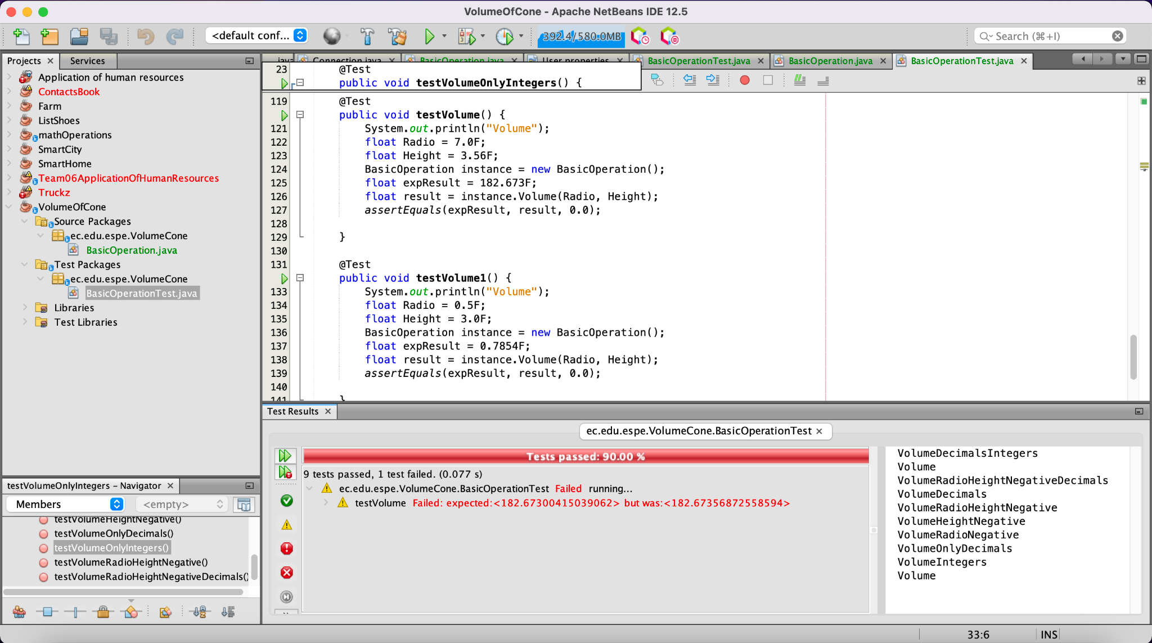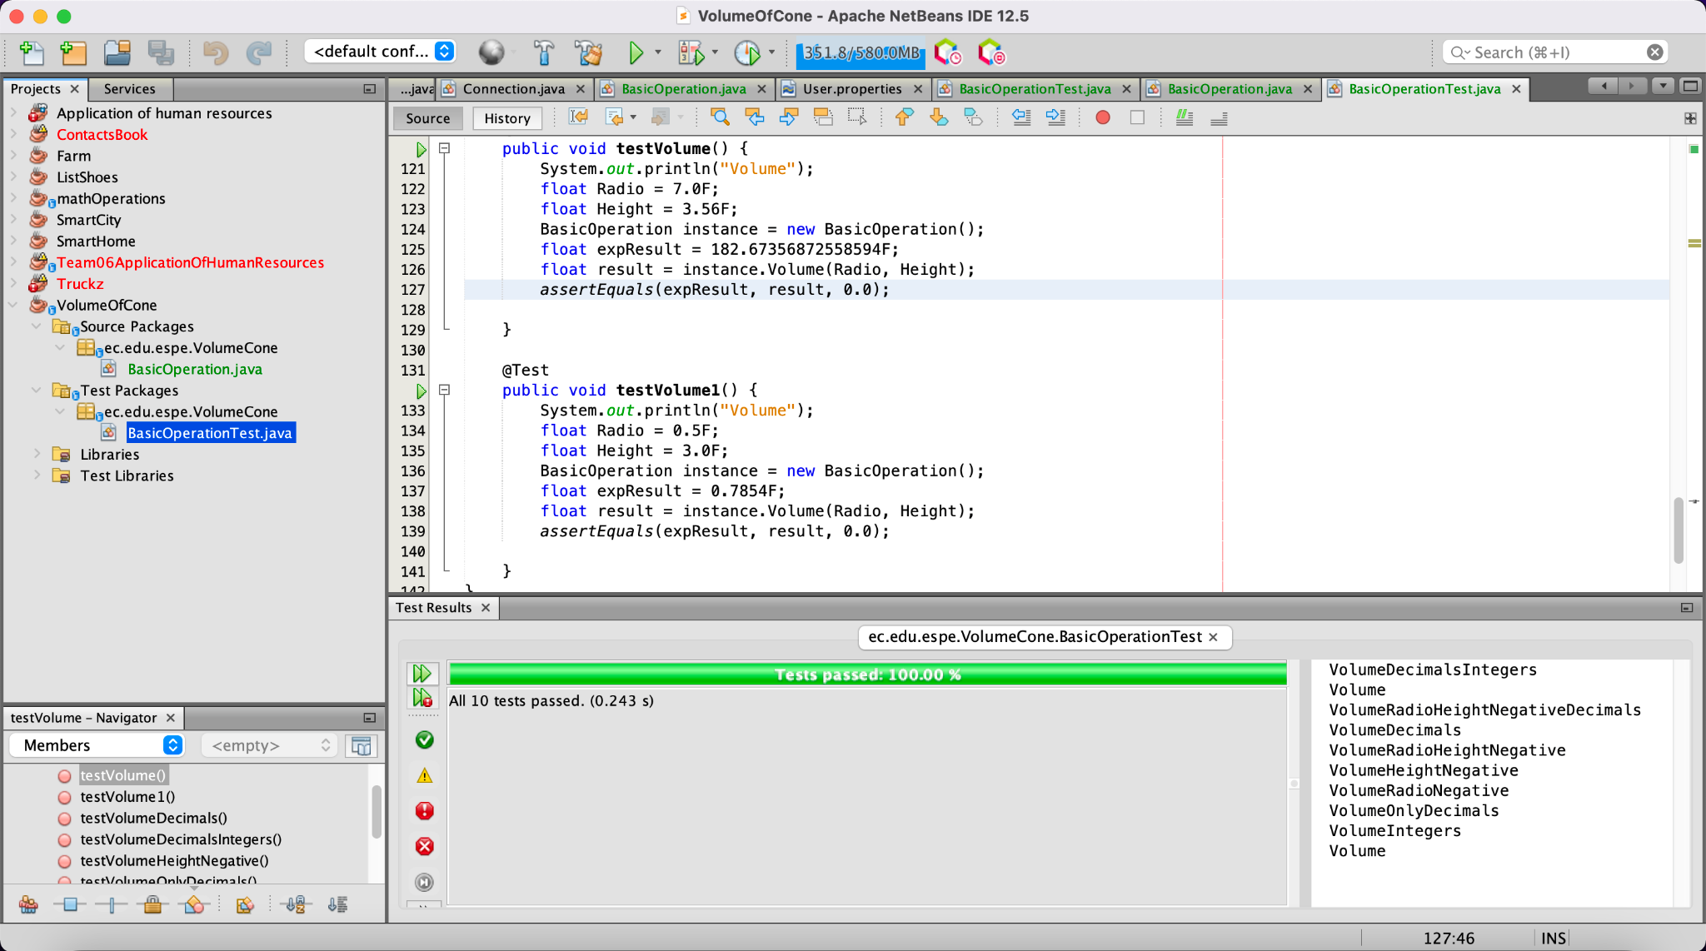

28 MANTUANO FERNANDEZ LEONEL FERNANDO

29 MORALES CAICEDO ANTHONY JAVIER

30 PALACIOS CANDO DIEGO SEBASTIAN

31 PAUCAR LEMA ALEX JAVIER

32 QUINGA GUAYASAMIN LEANDRO ALEXANDER

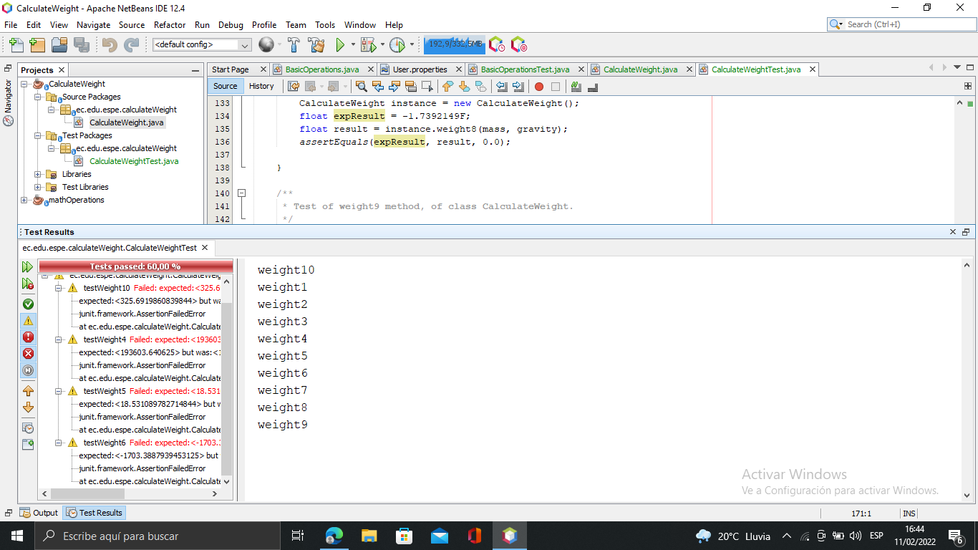

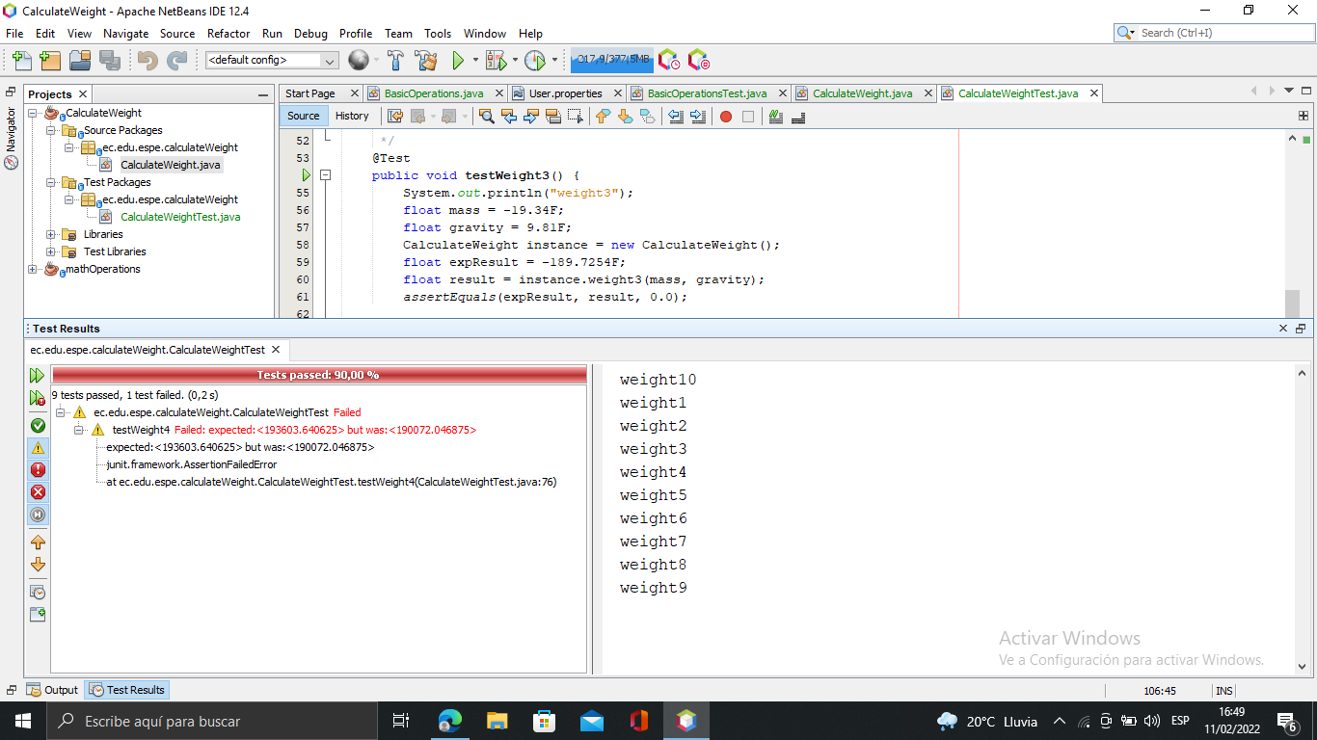

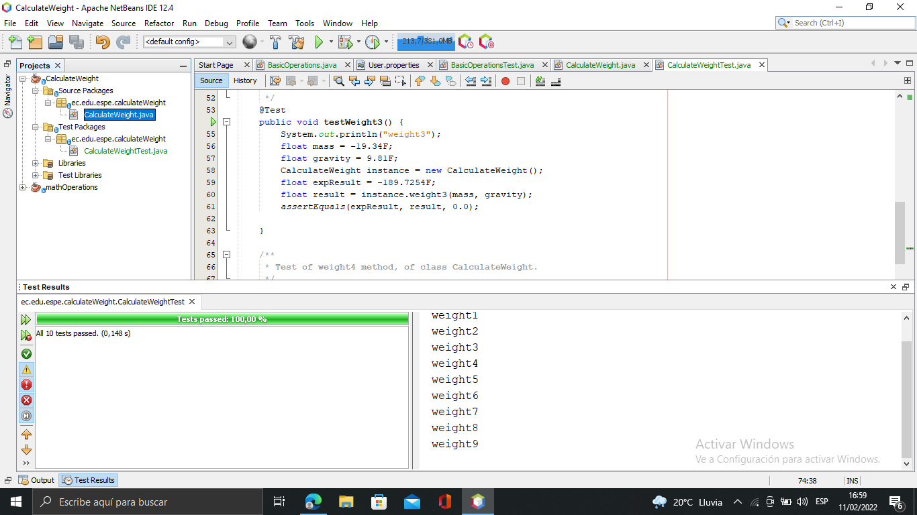

33 RUANO PONCE ALEXANDER JAVIER

34 SALTOS TACO PAUL ALEXANDER

35 SANCHEZ MISHQUERO JOSE FRANCISCO

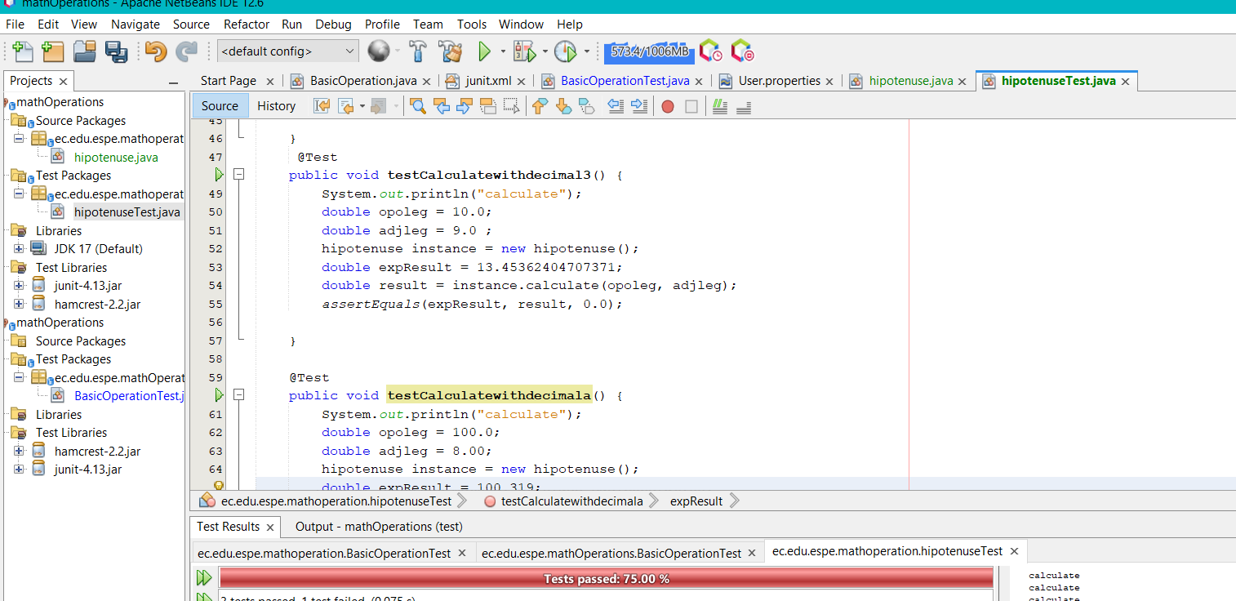

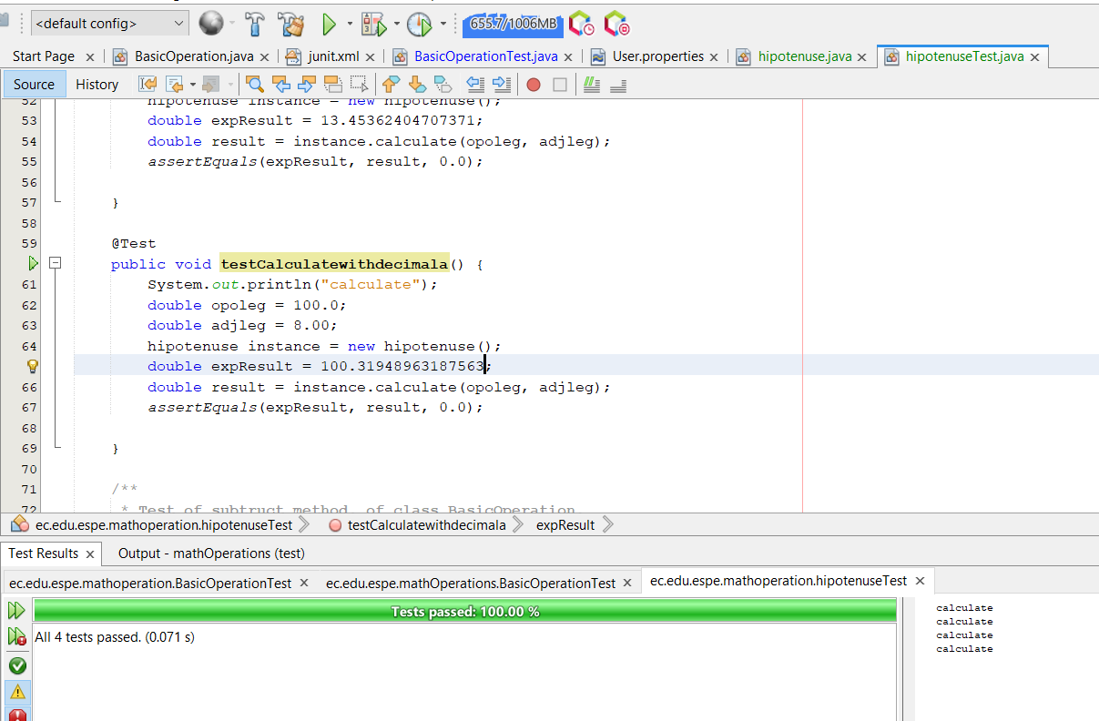

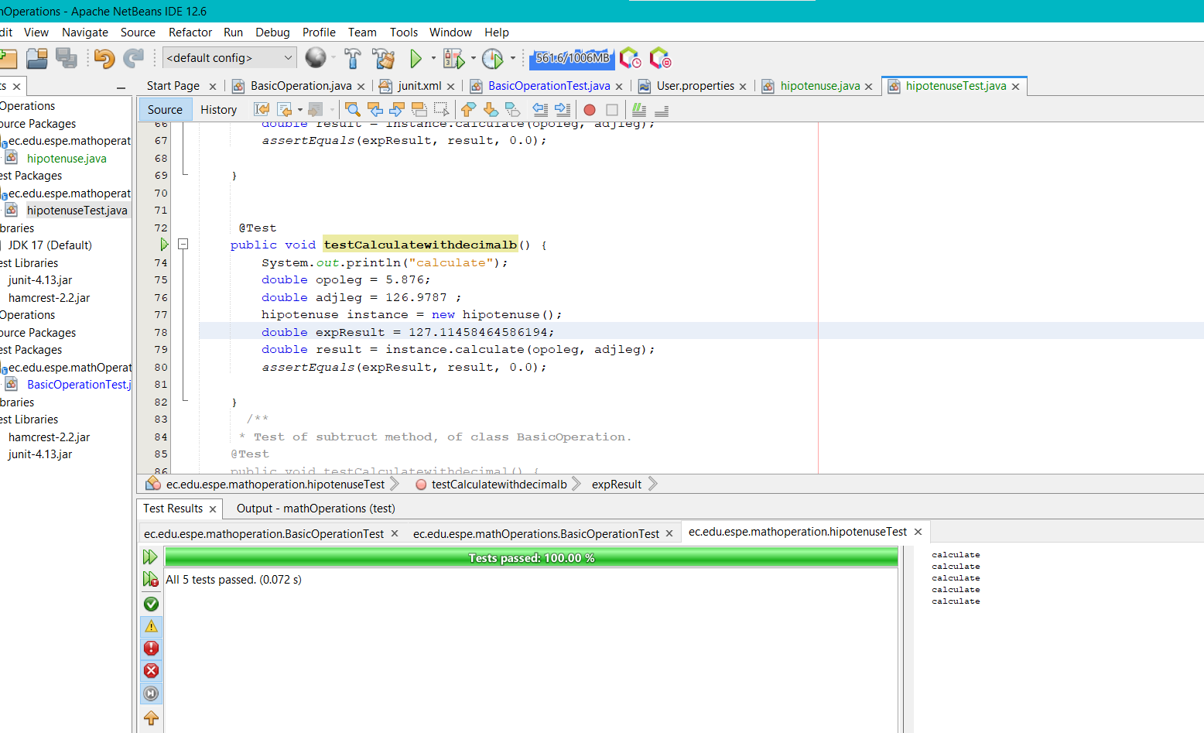

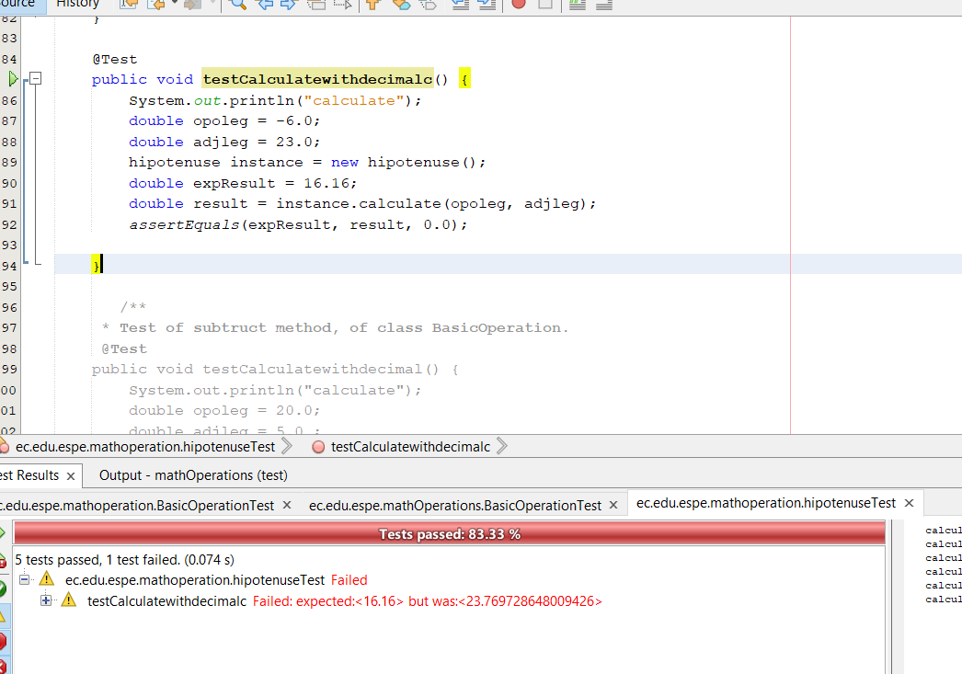

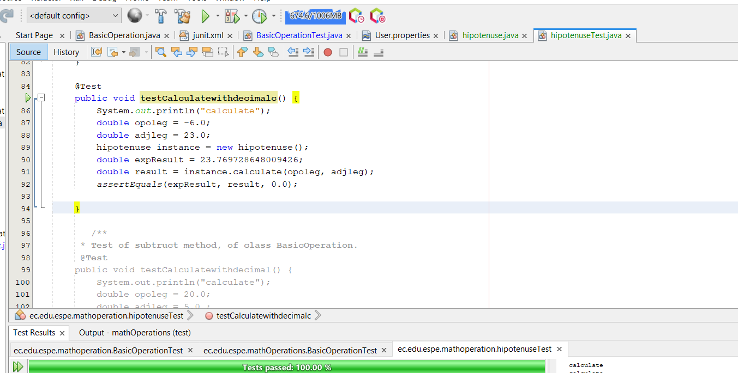

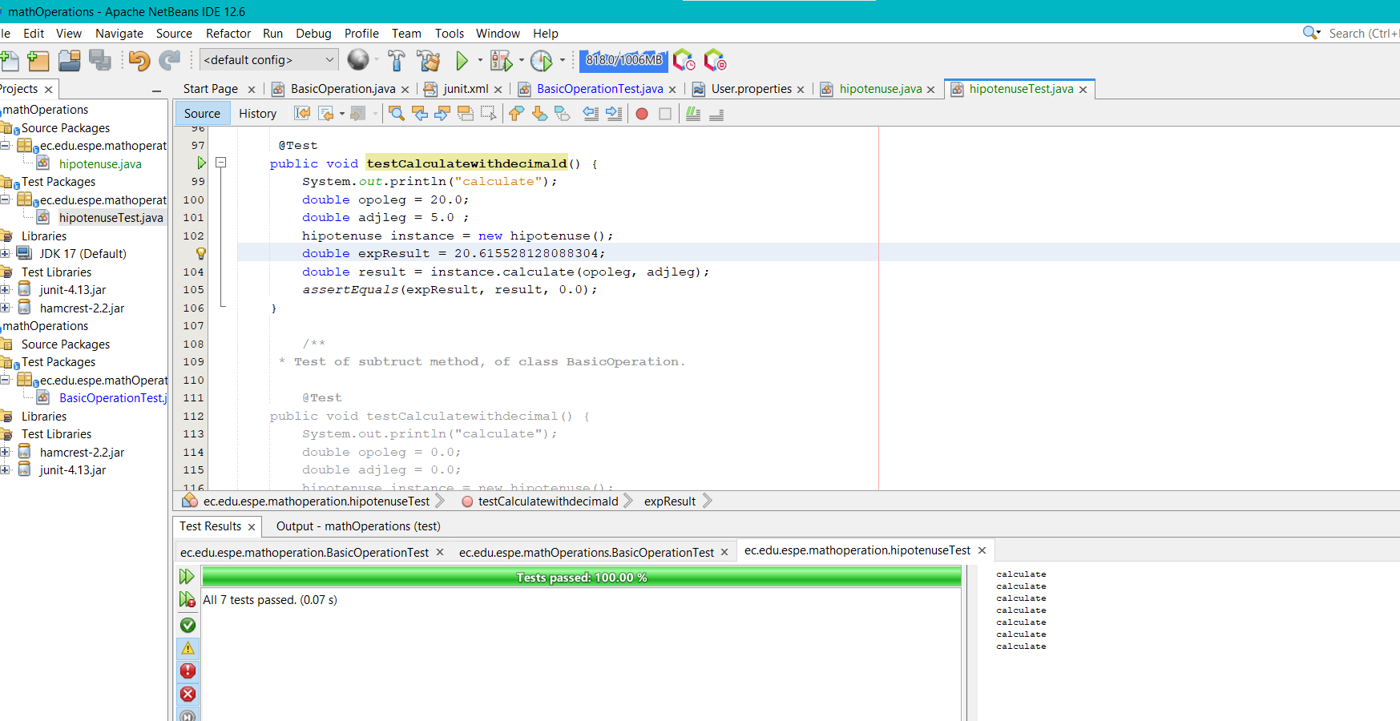

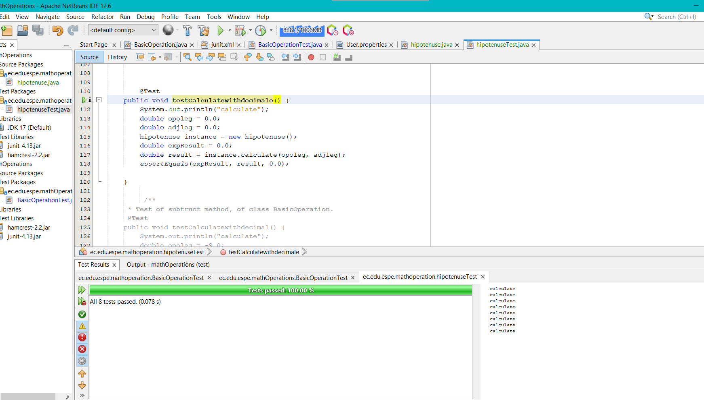

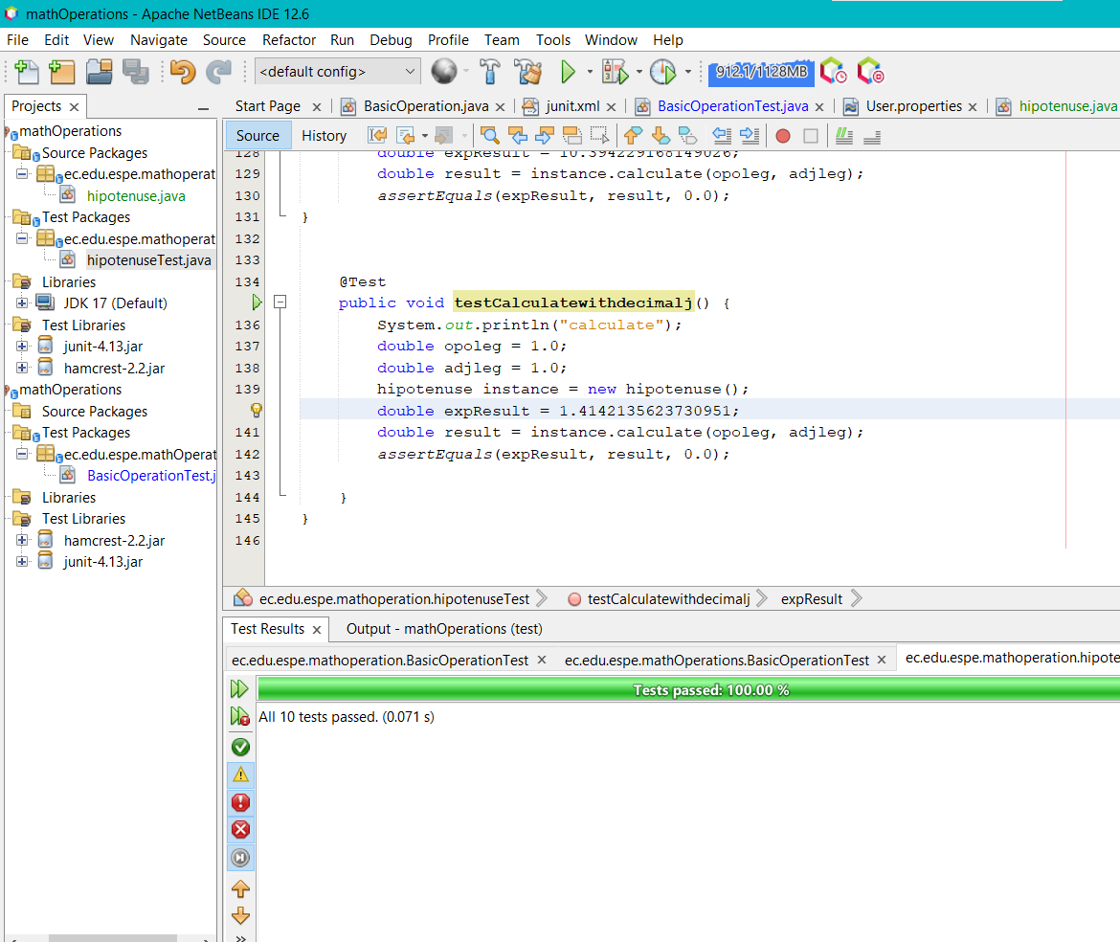

36 SHUGULI REINOSO ALAN JESITH

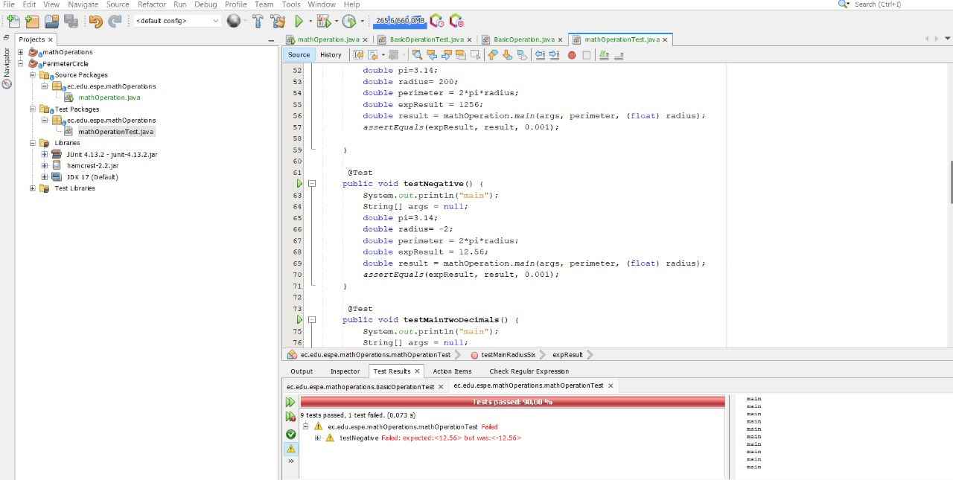

37 SIMBAÑA SIMBAÑA JONATHAN GUSTAVO

38 TAPIA ALBAN ANDREA JULIANNA

39 TAYO RUIZ SEBASTIAN ALEJANDRO

40 TECA TELLO CAMILA MILENA

41 TERAN FLORES MELANIE ELIZABETH

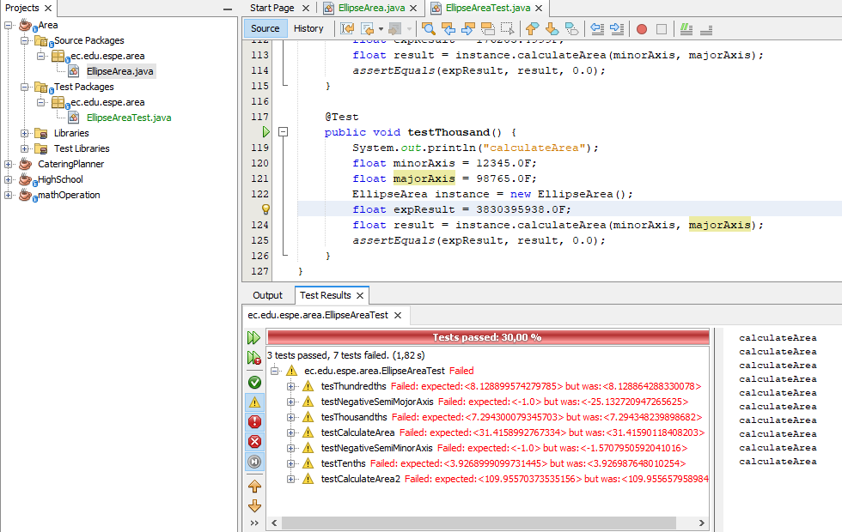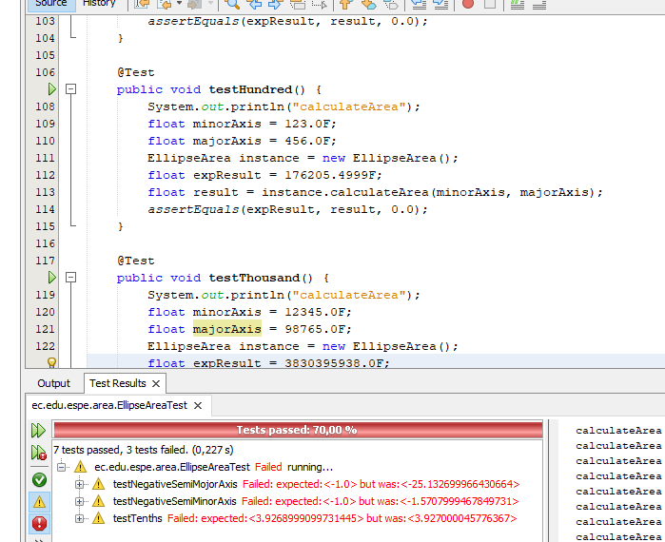

42 VILLEGAS ESTRELLA SALMA ABIGAIL

43 ZEAS CLAVIJO JOEL ALEXANDER